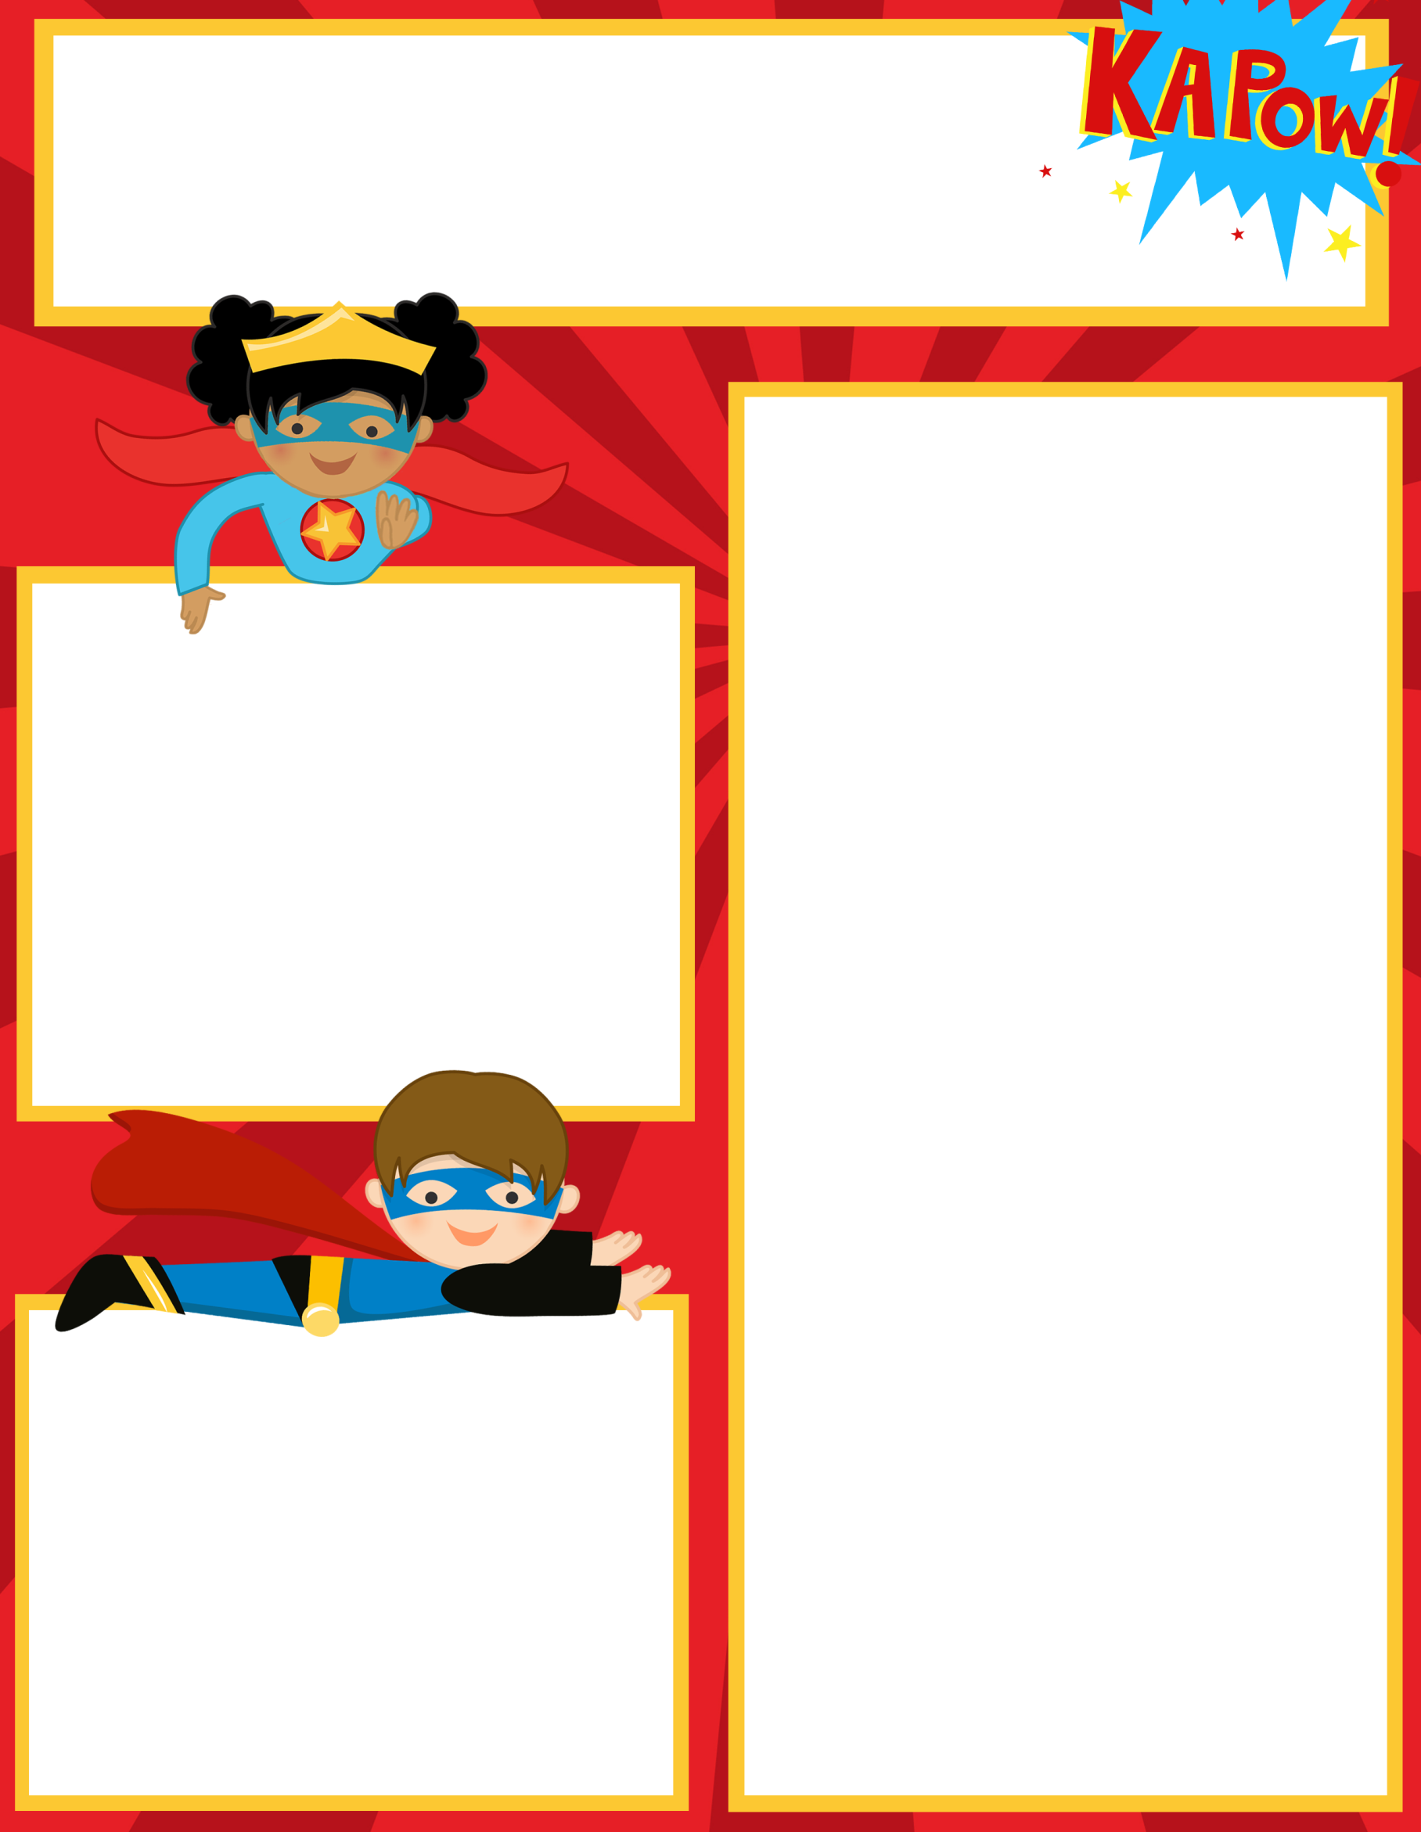Adh

**Reminders**

**Your child’s meal benefits from last year will expire on September 12th. Please submit an application for this year to either your child’s school cafeteria manager or directly to the district’s School Nutrition dept. as soon as possible. If a new application is not received by Sept. 12th, your child will have to pay full price for meals beginning September 13th.**

**Please remember check/sign your child’s agenda nightly.**

**Spelling Homework is due on Fridays!**

**What we are learning:**

**Reading/Lang Arts:** Reading Fluency, and Comprehension-story sequencing. Novel Study-Fourth Grade Rats

Language Arts: Parts of Speech-Adjectives, Verbs, Review Nouns

**Writing: Sentence Structure/Cursive Handwriting practice**

**Math:** Number Sense-Place Value to Thousands

Facts Practice- Review double digit addition and subtraction with regrouping and facts fluency

So**cial Studies**: Native Americans-Hopi, Seminole, Nez Perez and Pawnee Tribes

**Science**: Water Cycle & Review Weather/Storms

________________________________________

Check out our class website!

<http://hcesmrscanadaclark.weebly.com/>

**Contact Information**

Mrs. Canada-Clark

Teacher Hours 7:30am-3:00pm

706-253-1880 Ext 160

[ChristinaCanadaClark@pickenscountyschools.org](mailto:ChristinaCanadaClark@pickenscountyschools.org)



Ms. Canada-Clark’s

Weekly Class News

Upcoming Events

September 19th-23rd-

Fall Break No School

Friday, September 14, 2017