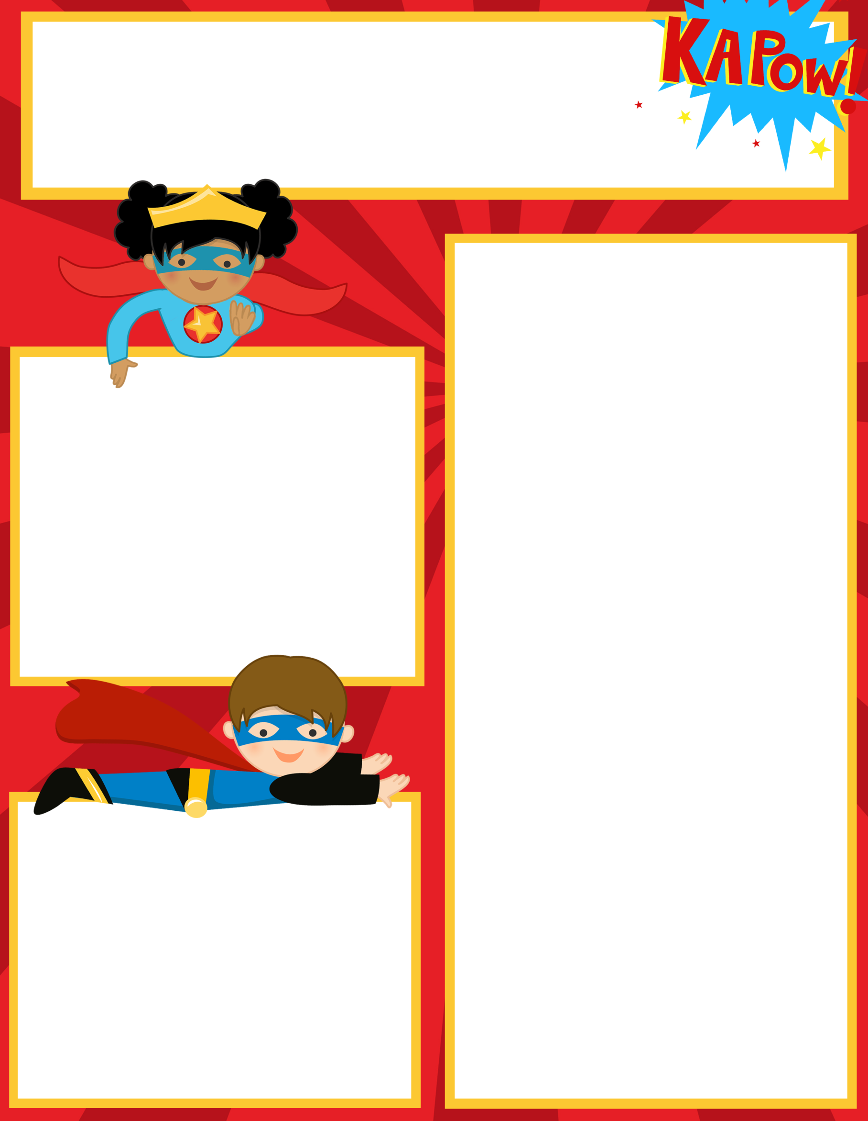Adh

**Upcoming Events**

**February 12: Valentine’s Due**

**February 14: Valentines Exchange**

**February 19: No School-Presidents Day**

**February 20: No School**

**February 21-23: School is In**

**What we are learning:**

**Reading/Lang Arts:** Reading Fluency, and Comprehension-story sequencing. Novel Study- Who is Abraham Lincoln? Who is George Washington?

Language Arts: Parts of Speech-Pronouns and Adjectives, Practice Fry Words

**Writing: Sentence Structure/Cursive Handwriting practice, Personal Narratives**

**Math:** Place Value, Comparing numbers, and Greater Than Less Than

Facts Practice- Review 2 and 3 digit addition and subtraction with and without regrouping and basic fact fluency: add, subtract, and multiplication facts

So**cial Studies**: Landforms and Historical Figures, Map Skills

**Science**: Plants and Animals

______________________________________

Check out our class website!

<http://hcesmrscanadaclark.weebly.com/>

**Contact Information**

Mrs. Canada-Clark

Teacher Hours 7:30am-3:00pm

706-253-1880 Ext 160

[ChristinaCanadaClark@pickenscountyschools.org](mailto:ChristinaCanadaClark@pickenscountyschools.org)



Ms. Canada-Clark’s

Weekly Class News

**Important Reminders**

**Please take a moment to complete the GA Parent Survey. You can find the link on the school website.**

**Please look in your child’s Friday Folder for important information.**

Friday, February 8, 2018