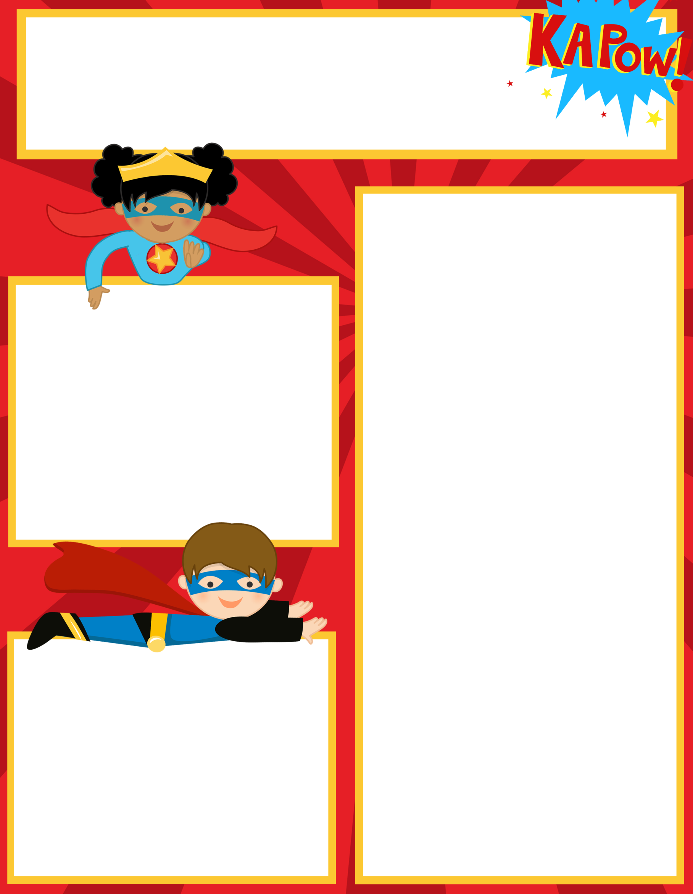Adh

**Upcoming Events**

**Dec 9: PTO Movie Night 6:00pm**

**Dec 15: HCES Dominos Pizza Night**

**Dec 16: Christmas Party 9:30-11:00**

**Dec 19-Jan 2: Christmas Break**

**What we are learning:**

**Reading/Lang Arts:** Reading Fluency, and Comprehension-story sequencing. Novel Study-Fourth Grade Rats

Language Arts: 4 Types of Sentences; Review Parts of Speech-Adjectives

**Writing: Sentence Structure/Cursive Handwriting practice, Personal Narratives**

**Math:** Multiplication Arrays

Facts Practice- Review Double digit addition and subtraction with regrouping and basic fact fluency

So**cial Studies**: Native Americans-Hopi, Seminole, Nez Perez, Inuit, Kwakiutl and Pawnee Tribes, Producers and Consumers

**Science**: Weather/Weather Instruments/Storms

______________________________________

Check out our class website!

<http://hcesmrscanadaclark.weebly.com/>

**Contact Information**

Mrs. Canada-Clark

Teacher Hours 7:30am-3:00pm

706-253-1880 Ext 160

[ChristinaCanadaClark@pickenscountyschools.org](mailto:ChristinaCanadaClark@pickenscountyschools.org)

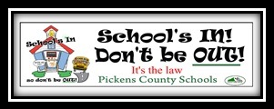

Ms. Canada-Clark’s

Weekly Class News

**Important Reminders**

**Yearbooks are on sale for $30 until**

**December 16th.**

**After Dec 16th they will be $35.00**

**Please take a few minutes to complete the GA Parent Survey. You can find the link on the school website.**

Friday, December 14, 2016