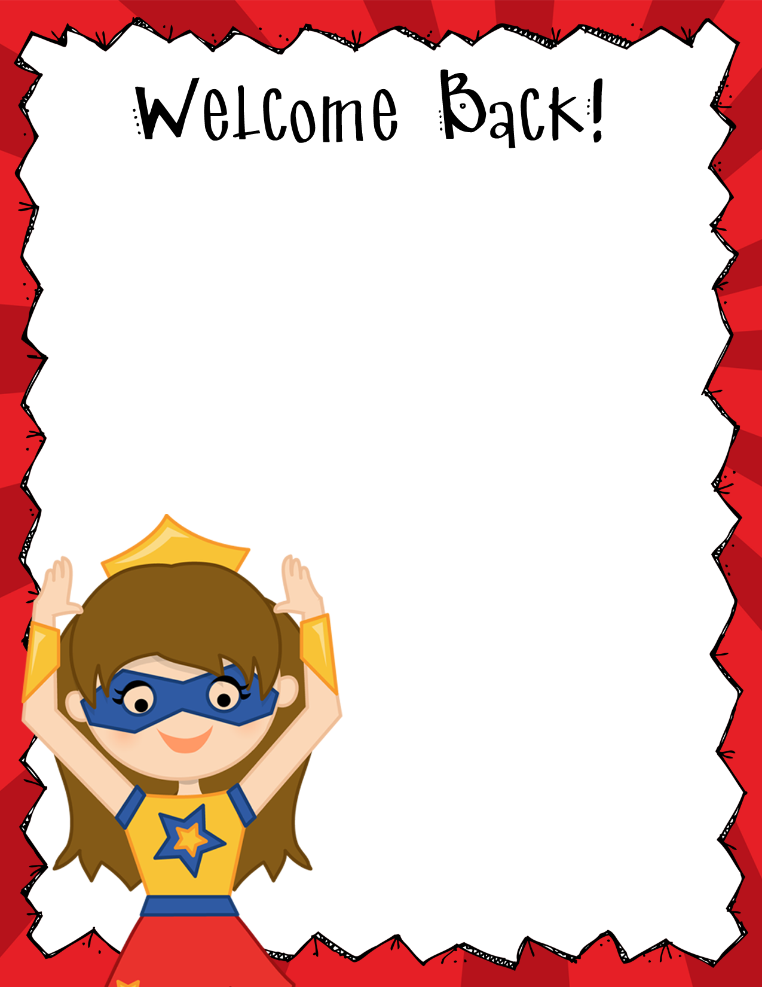

I will also keep in constant contact with you regarding your child’s academic gains and/or struggles. If I have any concerns, I will contact you immediately. Moreover, if you feel there is a concern, please contact me as soon as possible. Together you and I can work to ensure that your child is successful.

Attached you will find several pages of important papers. This is for your information. Please keep them in a safe place.

I know we are going to have a FABULOUS year! If you need anything, please feel free to contact me.

Sincerely,

Mrs. Canada-Clark

[christinacanadaclark@pickenscountyschools.org](mailto:christinacanadaclark@pickenscountyschools.org)

(706) 253-1880 Ext 160

Dear Parents,

It’s going to be a FABULOUS year! This year will be filled with excitement, fun and lots of learning. Your child will be given the tools and the opportunities to really explore knowledge. I believe that learning can be an enjoyable journey, where in the end we can all grow and develop a true love of wisdom and discover our strengths and passions.

I value open communication between school and home. I will keep in constant communication with you concerning the events in our classroom.